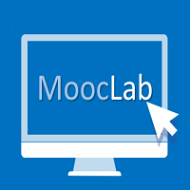

Free one-year membership to SitePoint Premium
Voucher
Terms & Conditions

The use of the Free one-year membership to SitePoint Premium voucher falls under the following terms and conditions:
- The competition is open to anyone who is 13 or older.
- This competition will award one (1) winner only which will be announced on 8th February, 2016.
- Only one (1) entry per participant is allowed.
- This competition will be open until 9pm GMT on 7th February 2016.
- The winner will be drawn at random from the full list of participants.
- The voucher is valid for one (1) one-year membership to SitePoint Premium at the date of issue referenced on the voucher.
- The voucher can be redeemed within 3 months from the date of issue referenced on the voucher.
- In order to receive the voucher, the winner is required to provide MoocLab with a valid name and e-mail address that will be used for registration on the SitePoint Premium website. This information will be passed on to the SitePoint Premium administrating team. We cannot be held responsible if the name and e-mail address is entered incorrectly or if a different name and e-mail address is used for registration on the SitePoint Premium website.
- The voucher is non-transferable, non-exchangeable, and not redeemable for cash or other prizes.
- The voucher is personal to its original recipient and cannot be transferred or reproduced in any form. MoocLab and SitePoint Premium reserve the right to withdraw a voucher at any time due to misconduct.

